**Purpose:**

Since this device is meant to be used by a variety of individuals due to its goal of being an open source device, we would like for it to be easy to set-up. In order to gauge ease of use we will use a user defined scale. With the assumption that whoever will be using the device is familiar to 3D printing, the test subjects would fall under this category and would be instructed to perform self evaluations using the following table:

| Rank | Description |
| --- | --- |
| 1 | The device cannot be set up, even with assistance |
| 2 | The device can be set up with assistance from a trained professional |
| 3 | The device can be set up while consulting an Assembly Manual |
| 4 | The device can be set up independently after several attempts |
| 5 | The device can be set up independently on first attempt |

**Target Test Criteria: Average Score ≥4**

**Results:**

Responses: 40

Average Score: 3.91875

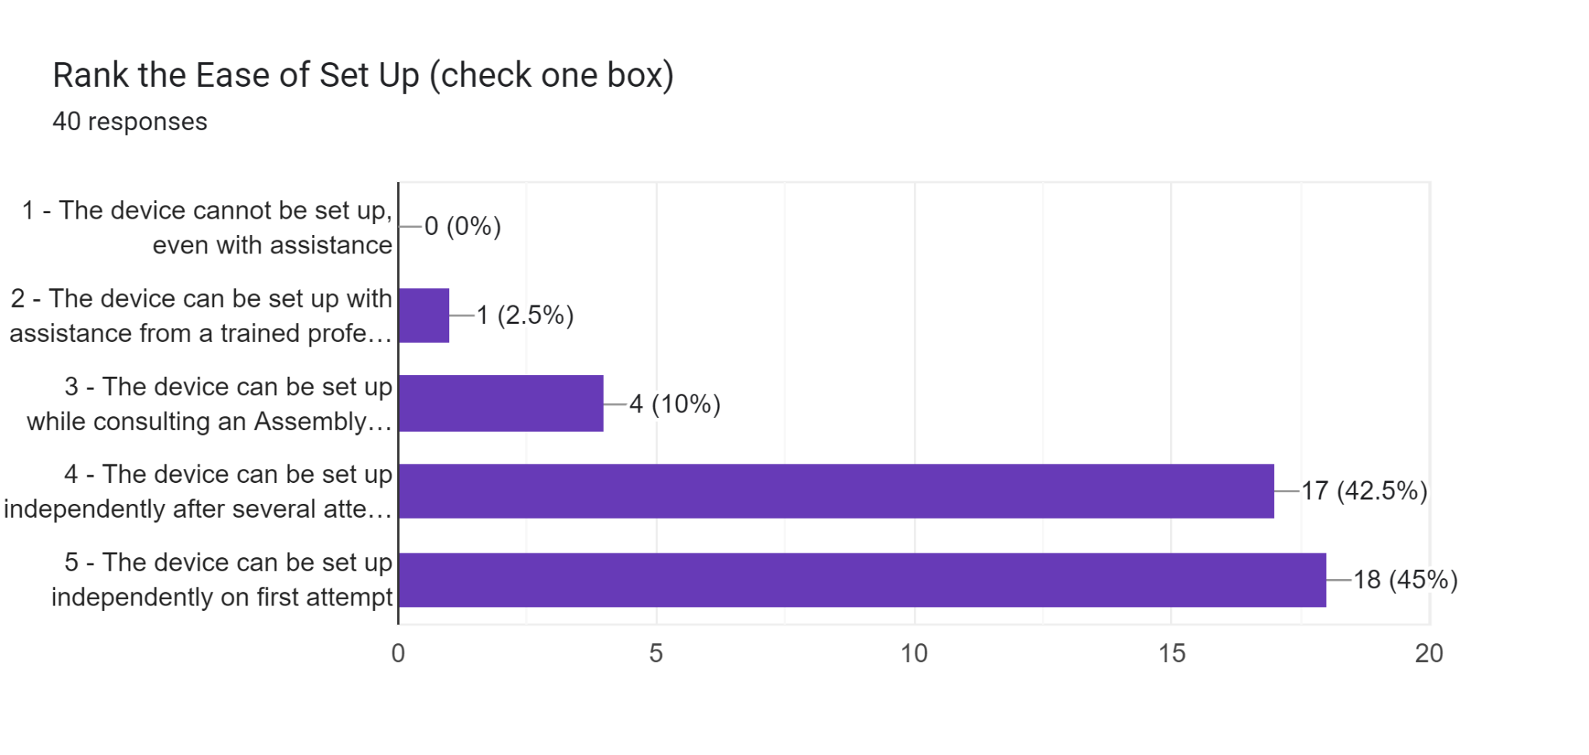

It should be noted that we changed our manual based on observations and recommendations that we and the participants noticed throughout the entirety of the experiments. If the participant didn’t need the manual, they didn’t have any input to the manual. It should be noted that the majority of the population that we tested had at least some experience with a 3D printer, with a few outliers who didn’t have any experience with it.